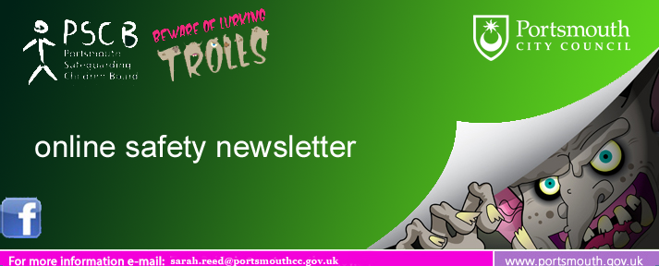
January 2017
Date for the Diary - Online Safety Event 21st June 2017 | 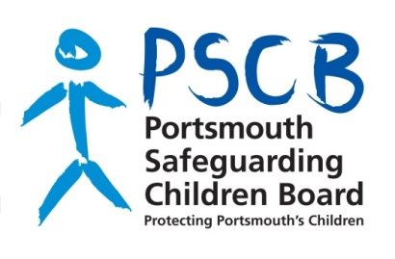  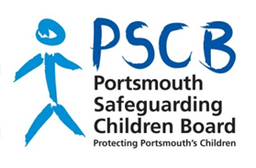        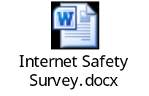      
The PCSB in collaboration with South West Grid for Learning, NSPCC, Barnardo's, Hants Constabulary and Sorted are hosting an Online Safety Training Day at Portsmouth Guildhall. This is the first place in the South East that the SWGFL are taking their interactive event. Professionals will get up to date information on current online safety issues and how to respond appropriately, as well as finding out about current initiatives and the services in Portsmouth. This event is free and you can book your place by emailing pscbtraining@portsmouthcc.gov.uk

Safer Internet Day Feb 7th 2017
Safer Internet Day 2017 will take place on Tuesday 7th February with the theme "Be the Change - unite for a better internet" and will be showcasing the power of images in digital youth culture today. Here is what you can do now:
- Register your school or organisation as a supporter
- Find out more about what will be happening for Safer Internet Day
- Launching soon there will be Education Packs and SID TV films to help explore these issues
Sexting Competition Hants Constabulary
Friday 18th November 2016 was the final of the Hampshire Constabulary Sexting Competition. 6 schools presented their entries. Amelix delivered the "is it worth it?" roadshow which is a dynamic interactive performance for secondary students Online safety.

Think you know resource for eight to ten year olds called Play like share
Play Like Share is a three-episode animated series and accompanying resource pack. It follows the adventures of Alfie, Ellie and Sam and aims to help children learn how to stay safe from sexual abuse, exploitation and other risks they might encounter online. The films can be downloaded on www.thinkuknow.co.uk/teachers,

Online Safety Workshop King Richards School November 2016
12 attendees came along to this workshop. Jo Mumford from PSHE Southampton kindly shared the survey she uses with junior school children to highlight online safety issues and then feedback to parents re. their children's online activity.

Cyberbullying Guidance and Practical PSHE toolkit
New resources launched as part of anti-bullying week 2016. There has been an 88% increase in calls to Childline regarding cyberbullying in the last five years.
http://www.childnet.com/new-for-schools/cyberbullying-guidance-and-practical-toolkit

Online Safety Training Day 29th March London
An informative and comprehensive Online Safety course in London. Cost to schools £250.00 per delegate. If anyone does attend, it would be great to receive an update and notes from the event.
www.safeguardingdigital.co.uk

Online Safety Training NSPCC
This new updated training is offered online and costs £30.00 It is a great foundation training package for all staff. Training takes 3½ hours and is in sections of 25 minutes.
NSPCC online Safety Training

"Crossing the line" PSHE toolkit for Online Safety.

A practical online safety PSHE toolkit with films and lesson plans to explore online issues with pupils aged 11-14 years old.

A PSHE Association Quality-Assured Resource http://www.childnet.com/resources/pshetoolkit

Online Safety Survey to reach you soon
The PCSB would like to assess local online safety awareness and the ability to respond to online safety issues via survey monkey. Results of the survey
will inform the June 21st Training day and provide a local picture of online safety and how the PCSB can support partner agencies.
Please do get in touch regarding any general online safety issues by emailing me at sarah.reed@portsmouthcc.gov.uk I work Fridays only in this role.

Please contact the MASH Team if there are immediate concerns regarding a young person on 02392 688793.


This email service is provided to the public by Portsmouth City Council. All dates, times and information are correct at the time of publication, but may be subject to change.

